Practical - 4
Practical Title: Responsive UI Design using CSS Grid, Flexbox, and
Bootstrap/Tailwind
Problem Definition: Add dynamic UI components such as collapsible FAQ, modal popup,
image/content slider, notification banner, hamburger menu, and light/dark
theme switcher using JavaScript.
F. Theory
1. Are correct input types and attributes used?
Answer: Yes. Standard HTML5 input types (type="email", type="password", type="text") and attributes (required, name, placeholder) are properly used.

2. Are validation errors displayed near the relevant fields?
Answer: Partially (Browser Defaults Only). It uses standard browser HTML5 popups on submit, but custom dynamic inline error messages next to fields are not currently added.

3. Is password strength checked?
Answer: Yes, typography, spacing, colors, and contrast directly determine whether text is readable. When properly balanced, they prevent eye strain and make content easy to scan. When poorly configured, text becomes difficult or impossible to read.

4. Is the form accessible using keyboard and screen-reader-friendly
labels?
Answer: style="" attributes. While they look like inline styles in the markup, they compile into clean external stylesheets and maintain design consistency without unnecessary true inline CSS.

- Evidence of Work (Screenshots)

1. Collapsible FAQ:-
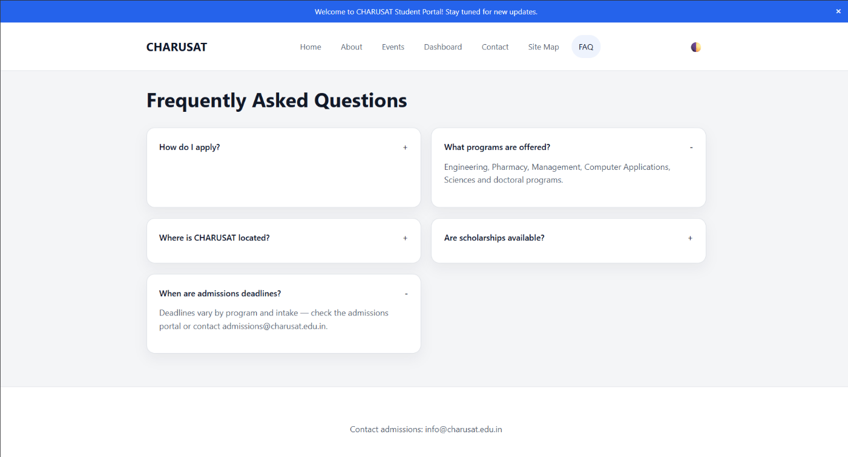
3. Content/Image Slider:-

4. Notification Banner:-
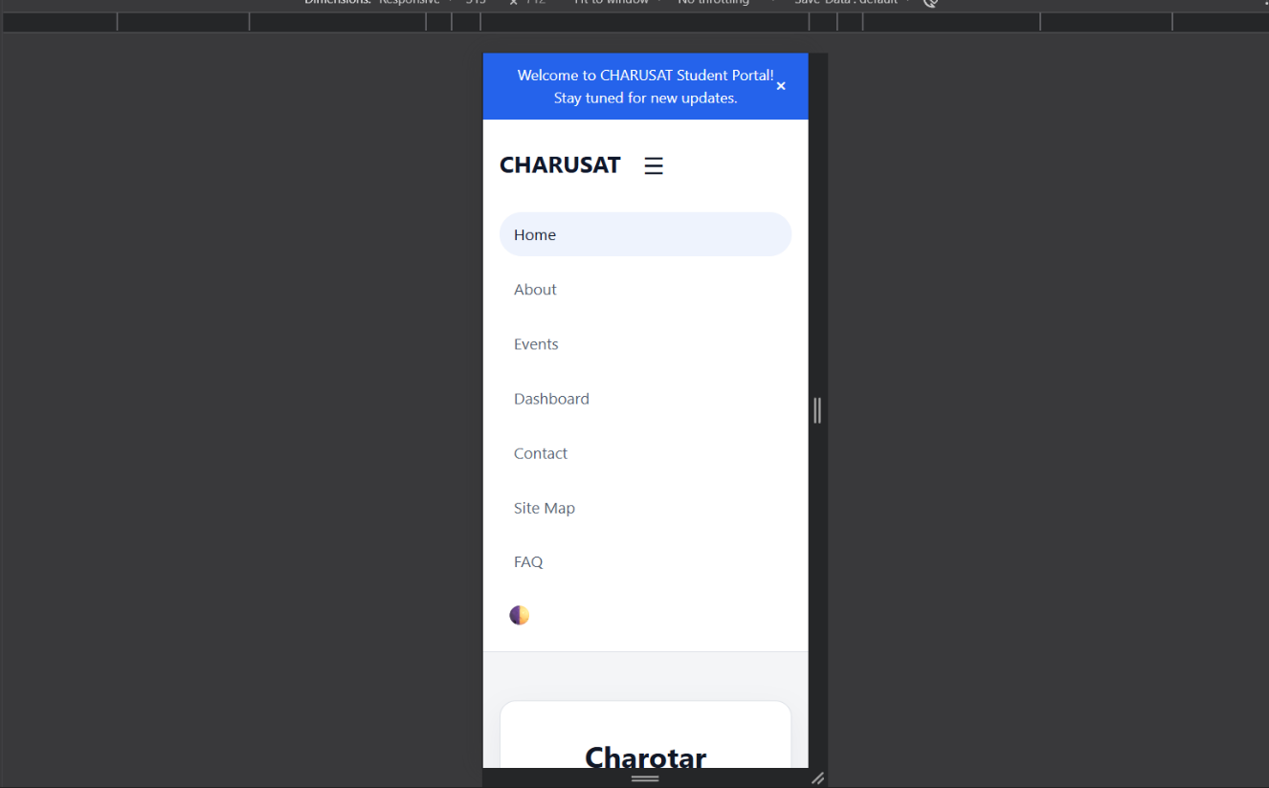
Hamburger Menu:-

Figure 3.3(Registration page)

6. Light/Dark Theme Switcher:-

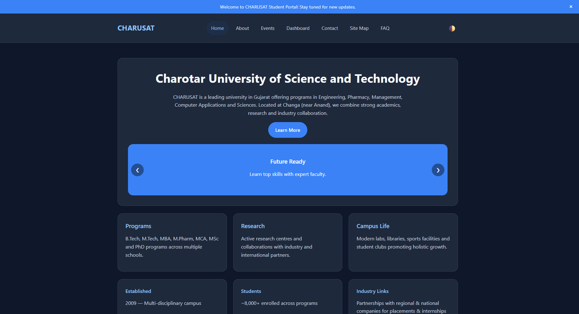

Repository Link :-
https://github.com/meet-3834/Student-Hub/tree/main/FINAL%20Submission

- Learning Outcomes:
I am able to apply JavaScript to enhance user experience and client-side
interactivity.

Faculty Remarks: (Keep this blank for faculty)

